ESS8 - Cultural Heritage
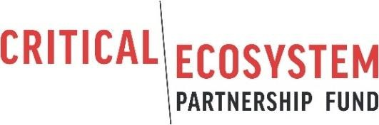

Cultural Heritage Plan

Date

CEPF Grant xxxxx Grantee
Sub-project Title

Sub-project Location

Grant Summary

- Grantee organization.
- Sub-project title.
- Grant number.
- Grant amount (US dollars).
- Proposed dates of grant.
- Countries where activities will be undertaken.
- Date of preparation of this document.

- Status of area to be impacted: This section will describe the legal designation of the site(s) where sub-project will be implemented.

- Cultural heritage present: This section will describe the elements of tangible and intangible cultural heritage present at the sub-project site(s), including a list of any legally protected cultural heritage areas.

- Project components: This section will briefly describe the sub-project, focusing on those components and activities that may involve impacts on cultural heritage.

- Potential risks and impacts: This section will describe the potential risks and impacts of the proposed activities of the sub-project on cultural heritage.

- Measures to preserve cultural heritage: This section will describe measures that will be taken to avoid adverse impacts or mitigate them, if avoidance is not possible. For sub-projects that explicitly aim to promote or preserve cultural heritage, this section will present a strategy for doing so.

- Timeline and resources: This section will present and implementation timeline for each measure listed in Section 12, together with an estimate of resource needs.

- Monitoring and arrangements: This section aims to outline what steps you will take to monitor and evaluate the effectiveness of the measures listed in Section 12.

- Consultation: This section will summarize the consultations carried out with stakeholders in preparation of the plan, particularly any local communities who may be particularly affected by the proposed activities. Include dates of consultations, and a summary of the number of women and men consulted, but do not include names of individuals.

- Disclosure: CEPF requires that environmental and social instruments are disclosed to affected local communities and other stakeholders prior to sub-project implementation. Please describe the efforts you have taken to disclose this Cultural Heritage Plan.

- Chance find procedure: A chance find procedure is a sub-project-specific procedure which will be followed if previously unknown cultural heritage is encountered during sub-project activities. It will

be included in all contracts relating to construction of the sub-project, including excavations, demolition, movement of earth, flooding or other changes in the physical environment.

The chance find procedure will set out how chance finds associated with the sub-project will be managed, and include requirements to:

  - Notify relevant authorities of found objects or sites by cultural heritage experts.
  - Fence-off the area of finds or sites to avoid further disturbance.
  - Conduct an assessment of found objects or sites by cultural heritage experts.
  - Identify and implement actions consistent with the requirements of this ESS and national law.
  - Train sub-project personnel and sub-project workers on chance find procedures.

