ESS4 - Community Health and Safety

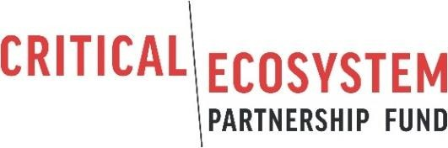

Community Health and Safety Plan

Date

CEPF Grant xxxxx Grantee
Sub-project Title

Sub-project Location

Grant Summary

- Grantee organization.
- Sub-project title.
- Grant number.
- Grant amount (US dollars).
- Proposed dates of grant.
- Countries where activities will be undertaken.
- Date of preparation of this document.

- Project components: This section will briefly describe the sub-project, focusing on those components and activities that may involve risks to the health and safety of communities at the sub- project site(s).

- Risks to community health and safety: This section will assess the risk of each activity, against criteria of probability and severity, and describe in detail all risks rated as moderate, substantial or high.

- Risk mitigation measures: This section will describe the measures that will be taken to mitigate all risks rated as moderate or above. Mitigation measures will be presented following the mitigation hierarchy, which requires that risks are anticipated and avoided where possible. Where avoidance is not possible, risks should be minimized to acceptable levels. Any risks that remain following avoidance and minimization should be mitigated.

- Measures to avoid risk of COVID-19: This section will describe the measures that will be taken to avoid the risk of COVID-19 transmission to communities at the sub-project site(s).

- Emergency preparedness and response plan: This section will present an outline of your emergency preparedness and response plan for emergency events, in particular hurricanes, earthquakes and (if relevant) volcanic eruptions.

- Measures to mitigate risks relating to security personnel: If the sub-project involves support to security personnel (park guards, community rangers, etc.), this section will describe the measures you will take in relation to hiring, rules of conduct, training, equipping, and monitoring the action of security personnel, to ensure they do not engage in unlawful or abusive acts against local people.

- Timeline and resources: This section will present and implementation timeline for each measure listed in Sections 10 to 13, together with an estimate of resource needs.

- Monitoring arrangements: This section will outline the steps you will take to monitor and evaluate the effectiveness of the measures listed in Sections 10 to 13.

- Disclosure: CEPF requires that environmental and social instruments are disclosed to affected local communities and other stakeholders prior to sub-project implementation. Please describe the efforts you have taken to disclose this plan.

